**Hydrolysis of Salts and Reactions of Acids and Bases**

**Example 1**

**Determining the Acidic or Basic Nature of Salts**  
Determine whether aqueous solutions of the following salts are acidic, basic, or neutral:

(a) KBr

(b) NaHCO3

(c) NH4Cl

(d) Na2HPO4

(e) NH4F

**Solution**  
Consider each of the ions separately in terms of its effect on the pH of the solution, as shown here:

(a) The K+ cation and the Br− anion are both spectators, since they are the cation of a strong base (KOH) and the anion of a strong acid (HBr), respectively. The solution is neutral.

(b) The Na+ cation is a spectator, and will not affect the pH of the solution; while the \text{HCO}_3^{\;\;-} anion is amphiprotic, it could either behave as an acid or a base. The *K*a of \text{HCO}_3^{\;\;-} is 4.7 × 10−11, so the *K*b of its conjugate base is \frac{1.0\;\times\;10^{-14}}{4.3\;\times\;10^{-7}} = 2.3\;\times\;10^{-8}.

Since *K*b >> *K*a, the solution is basic.

(c) The \text{NH}_4^{\;\;+} ion is acidic and the Cl− ion is a spectator. The solution will be acidic.

(d) The Na+ ion is a spectator, while the \text{HPO}_4^{\;\;2-} ion is amphiprotic, with a *K*a of 4.2 × 10−13 so that the *K*b of its conjugate base is \frac{1.0\;\times\;10^{-14}}{6.2\;\times\;10^{-8}} = 1.6\;\times\;10^{-7}. Because *K*b >> *K*a, the solution is basic.

(e) The \text{NH}_4^{\;\;+} ion is listed as being acidic, and the F− ion is listed as a base, so we must directly compare the *K*a and the *K*b of the two ions. *K*a of \text{NH}_4^{\;\;+} is 5.6 × 10−10, which seems very small, yet the *K*b of F− is 1.4 × 10−11, so the solution is acidic, since *K*a > *K*b.

**Try yourself**  
Determine whether aqueous solutions of the following salts are acidic, basic, or neutral:

(a) K2CO3

(b) CaCl2

(c) KH2PO4

(d) (NH4)2CO3

(e) AlBr3

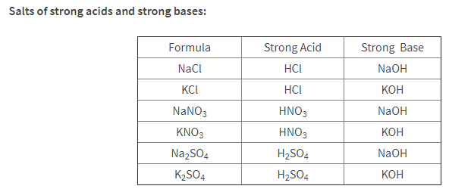

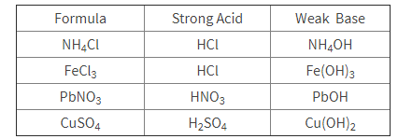

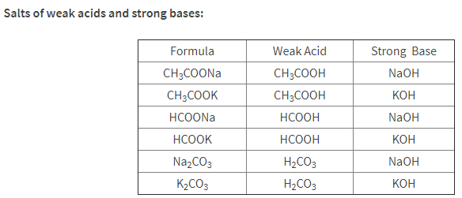

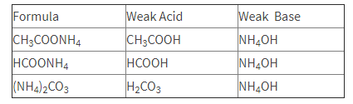

Describe each as an acid, base, neutral salt, acidic salt, or basic salt. For each salt write a parent acid-base formation equation, dissociation equation, and hydrolysis equation (only for acidic and basic salts). For acids and bases write an equation to show how each reacts with water.

1. NH3

2. KCl

3. HNO3

4. NaHCO3

5. RbOH

6. AlCl3

7. H2C2O4

8. NaC6H5O

9. Co(NO3)3

10. Na2CO3

**Hydrolysis of Salts and Reactions of Acids and Bases**

Describe each as an acid, base, neutral salt, acidic salt, or basic salt. For each salt write a dissociation equation and hydrolysis equation (only for acidic and basic salts). For acids and bases write an equation to show how each reacts with water.

1. NH3

2. NaCl

3. HCl

4. NaCN

5. NaOH

6. FeCl3

7. HF

8. LiHCO3

9. Fe(NO3)3

10. MgCO3

11. H2S

12. HF

13. CaI2

14. Mg(OH)2

15. Ba(OH)2

16. Describe why Tums (CaCO3) neutralizes stomach acid.

17. Describe why Mg(OH)2 is used in Milk of Magnesia as an antacid instead of NaOH.

**ANSWERS**

**WS # 1 Hydrolysis of Salts and Reactions of Acids and Bases**

Describe each as an acid, base, neutral salt, acidic salt, or basic salt. For each salt write a parent acid-base formation equation, dissociation equation, and hydrolysis equation (only for acidic and basic salts). For acids and bases write an equation to show how each reacts with water.

1. NH3 **weak base**

**NH3 + H2O ⇄ NH4+ + OH-**

2. KCl **neutral salt**

**HCl + KOH → KCl + H2O**

**KCl → K+ + Cl-**

3. HNO3 **strong acid**

**HNO3 + H2O → H3O+ + NO3-**

4. **NaHCO3** **basic salt**

**H2CO3 + NaOH → NaHCO3 + H2O**

**NaHCO → Na+ + HCO3-**

**HCO3- + H2O ⇄ H2CO3 + OH-**

5. RbOH **strong base**

**RbOH → Rb+ + OH-**

6. AlCl3 **acid salt**

**3HCl + Al(OH)3 → AlCl3 + 3H2O**

**AlCl3** **→ Al+3 + 3Cl-**

**Al(H2O)63+ ⇄ Al(H2O)5(OH)2+ + H+**

7. H2C2O4 **weak acid**

**H2C2O4 + H2O ⇄ H3O+ + HC2O4-**

8. NaC6H5O **basic salt**

**C6H5OH + NaOH → NaC6H5O+ H2O**

**NaC6H5O → Na+ + C6H5O-**

**C6H5O- + H2O ⇄ C6H5OH + OH-**

9. Co(NO3)3 **acid salt**

**3HNO3 + Co(OH)3 → Co(NO3)3 + 3H2O**

**Co(NO3)3** **→ Co+3 + 3NO3-**

**Co(H2O)63+ ⇄ Co(H2O)5(OH)2+ + H+**

10. Na2CO3 **basic salt**

**H2CO3 + 2NaOH → Na2CO3 + 2H2O**

**Na2CO3 → 2Na+ + CO3-2**

**CO3-2 + H2O ⇄ HCO3-  + OH-**

**WS # 2 Hydrolysis of Salts and Reactions of Acids and Bases**

Describe each as an acid, base, neutral salt, acidic salt, or basic salt. For each salt write a parent acid-base formation equation, dissociation equation, and hydrolysis equation (only for acidic and basic salts). For acids and bases write an equation to show how each reacts with water.

1. NH3 **weak base**

**NH3 + H2O ⇄ NH4+ + OH-**

2. NaCl **neutral salt**

**NaCl → Na+ + Cl-**

3. HCl **strong acid**

**HCl + H2O → H3O+ + Cl-**

4. NaCN **basic salt**

**NaCN → Na+ + CN-**

**CN- + H2O ⇄ HCN + OH-**

5. NaOH **strong base**

**NaOH → Na+ + OH-**

6. FeCl3 **acid salt**

**FeCl3** **→ Fe+3 + 3Cl-**

**Fe(H2O)63+ ⇄ Fe(H2O)5(OH)2+ + H+**

7. HF **weak acid**

**HF + H2O ⇄ H3O+ + F-**

8. LiHCO3 **basic salt**

**LiHCO3 → Li+ + HCO3-**

**HCO3- + H2O ⇄ H2CO3 + OH-**

9. Fe(NO3)3 **acid salt**

**Fe(NO3)3** **→ Fe+3 + 3NO3-**

**Fe(H2O)63+ ⇄ Fe(H2O)5(OH)2+ + H+**

10. MgCO3 **basic salt**

**MgCO3 → Mg+2 + CO3-2**

**CO3-2 + H2O ⇄ HCO3-  + OH-**

11. H2S **weak acid**

**H2S + H2O ⇄ H3O+ + HS-**

12. HF **weak acid**

**HF + H2O ⇄ H3O+ + F-**

13. CaI2 **neutral salt**

**CaI2 → Ca+2 + 2I-**

14. Mg(OH)2 **weak base**

**Mg(OH)2  ⇄ Mg+2 + 2OH-**

15. Ba(OH)2 **strong base**

**Ba(OH)2  → Ba+2 + 2OH-**

16. Describe why Tums (CaCO3) neutralizes stomach acid. **It is a weak base and will neutralize acid.**

**basic salt**

**CaCO3 → Ca+2 + CO3-2**

**CO3-2 + H2O ⇄ HCO3-  + OH-**

17. Describe why Mg(OH)2 is used in Milk of Magnesia as an antacid instead of NaOH.

**Mg(OH)2 is** **weak base and releases OH- slowly, whereas NaOH is a strong base which releases OH- in high concentrations which is corrosive.**

**Mg(OH)2  ⇄ Mg+2 + 2OH-**

**NaOH → Na+ + OH-**